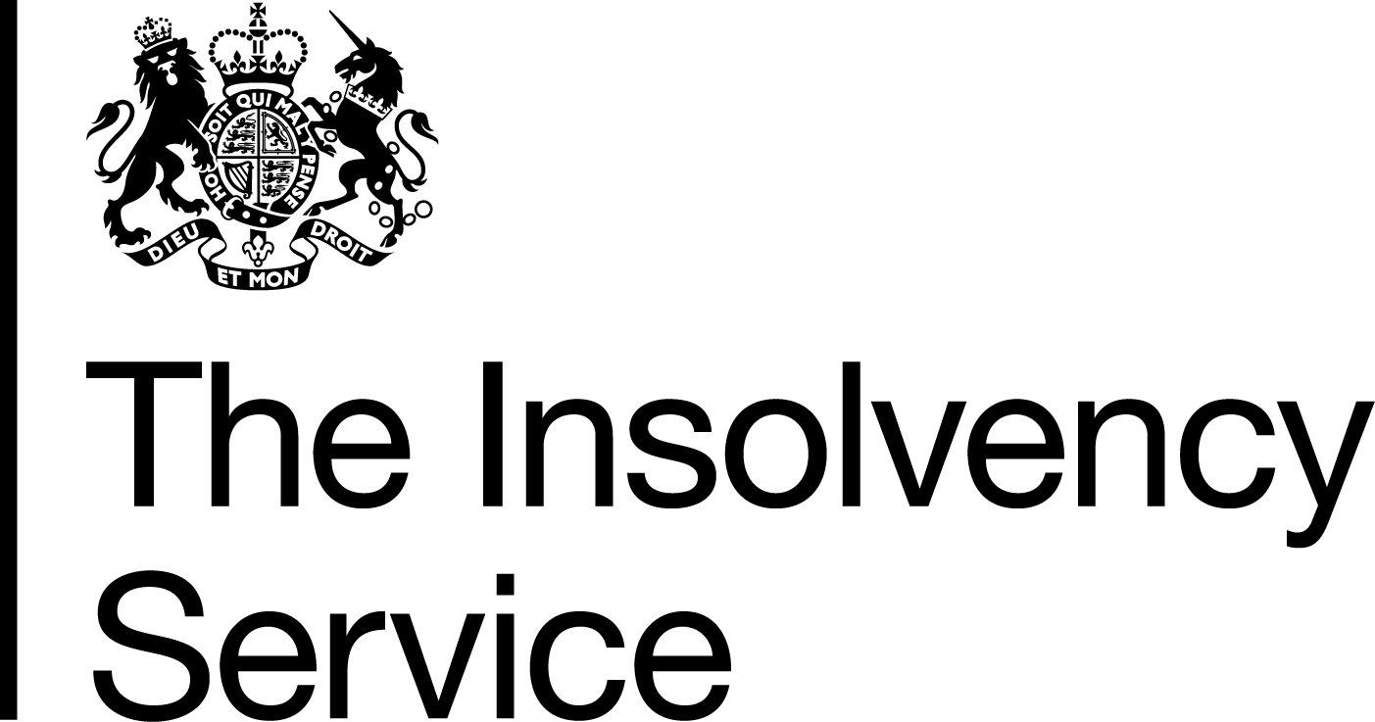 | Insolvency Practitioner Regulation Section  3rd Floor  Abbey Orchard Street  London  SW1P 2HT  Tel: 020 7291 6772  www.gov.uk/insolvency-service

DEAR INSOLVENCY PRACTITIONER

Issue 89 – July 2019

Message from Angela Crossley
Head of Insolvency Practitioner Regulation

Dear Reader

Attached is a special edition of Dear IP concerning a Call for Evidence which has been issued by Government relating to the regulation of insolvency practitioners.

The Insolvency Service has published a Call for Evidence on the current regulatory framework for insolvency practitioners. The document seeks evidence on the impact of statutory regulatory objectives for the insolvency profession, introduced by SBEE Act in October 2015. This will help inform government whether the regulatory objectives have had their intended impact or whether there is a need to make further changes to the regulatory landscape.

We welcome your responses as part of the evidence gathering process.

In this issue:
Information/Notes page(s):
Chapter 13 | General
Article 99 | Review of the Regulation of Insolvency Practitioners: A Call for Evidence

- Review of the Regulation of Insolvency Practitioners: A Call for Evidence

The Insolvency Service has issued a Call for Evidence which aims to gather views on the current regulatory framework for insolvency practitioners. The document seeks views on a number of areas and also looks to assess the impact of statutory Regulatory Objectives for the insolvency profession, introduced by The Small Business Enterprise and Employment Act 2015 (SBEEA 2015) in October 2015

The Regulatory Objectives were brought in alongside a number of other measures in order to help increase transparency and improve consistency of outcomes in the regulatory sphere.

The Call for Evidence paper seeks responses to questions on 3 key areas:

- Impact of the Regulatory Objectives
- Confidence in the current regulatory framework
- Suggestions for a new/alternative regulatory framework, including a single regulator

The “SBEEA 2015” includes a reserve power, expiring in October 2022 to enable the Secretary of State to make regulations to establish a single regulator of insolvency practitioners.

Responses to the Call for Evidence will help inform Government whether there is need for a further consultation on a single regulator or alternative options to amend the regulatory framework.

It is important to emphasise that the power to create a single regulator of insolvency practitioners will not be exercised without a full consultation and cost/benefit analysis of any proposed reforms.

The Insolvency Service is engaging with key stakeholders including with R3 and the Recognised Professional Bodies. We welcome responses from insolvency practitioners which will feed into the evidence gathering process.

A link to the Call for Evidence document can be found here: https://www.gov.uk/government/consultations/call-for-evidence-regulation-of-insolvency-practitioners-review-of-current-regulatory-landscape
Responses are sought by 4th October 2019.

General queries may be sent to email IPregulation.Review@insolvency.gov.uk

(Back to top)

