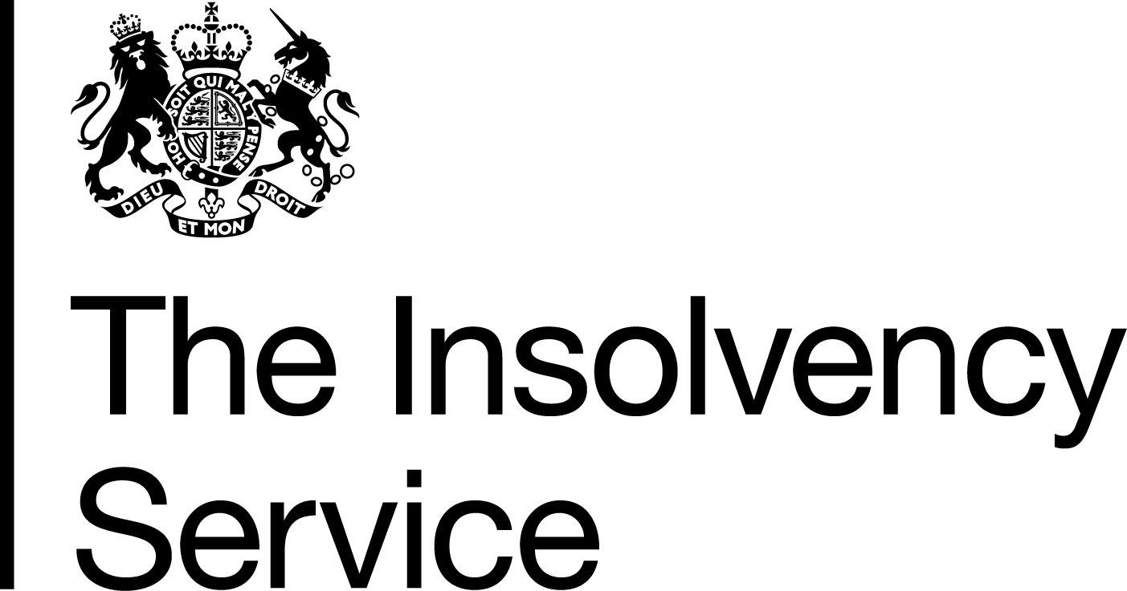 | Insolvency Practitioner Regulation Section  3rd Floor  Abbey Orchard Street  London  SW1P 2HT  Tel: 020 7291 6772  www.bis.gov.uk/insolvency

DEAR INSOLVENCY PRACTITIONER

Issue 86 – March 2019

Message from Angela Crossley
Head of Insolvency Practitioner Regulation

Dear Reader

Attached is a special edition of Dear IP concerning The Insolvency (Amendment) (EU Exit) Regulations 2018.

These Regulations deal with the scenario where the UK leaves the EU without a deal on insolvency. The Regulations have now been enacted by each House of Parliament and were made on 30th January 2019. They will come into effect on the day the UK leaves the EU if we leave without a deal on insolvency. The Article also deals with The Provision of Services Amendment (EU Exit) Regulations 2018 and The Insolvency (EU Exit) (Scotland) (Amendment) Regulations 2019 detailing amendments to the Insolvency Practitioners Regulations concerning IP insurance and devolved Scottish Insolvency provisions respectively.

In this issue:
Information/Notes page(s):
Chapter 15 | Insolvency Rules, Regulations and Orders
Article 64 | EU Exit statutory instruments (“No Deal”)

64) EU Exit statutory instruments (“No Deal”)

We informed readers in November 2018 that we had laid The Insolvency (Amendment) (EU Exit) Regulations 2019 as part of the Governments plans to prepare for the possibility of the UK leaving the EU without a deal.

The Regulations have now been enacted by each House of Parliament and were made on 30 January 2019. They will come into effect on the day the UK leaves the EU. The only exception to this are certain Northern Ireland regulations that came into effect the day after the regulations were made and were to align insolvency and employment laws in Northern Ireland with those in England, Wales and Scotland.

In addition on 12 November 2018 The Provision of Services Amendment (EU Exit) Regulations 2018 were laid before Parliament as a “negative” instrument. The Regulations amend the Provision of Services Regulations 2009. In addition, it revokes parts of the Provision of Services (Insolvency Practitioners) Regulations 2009 and the Provision of Services (Insolvency Practitioners) Regulations (Northern Ireland) 2009, and makes amendments to the Insolvency Practitioner Regulations 2005.

These changes reflect that in a ‘no deal’ scenario, the EU Services Directive will no longer apply to the UK. The laws around insurance will be amended to ensure that EEA insolvency practitioners are on a level playing field with those in the UK, by ensuring they meet the same insurance requirements. The Secretary of State for Business, Energy and Industrial Strategy will no longer have to recognise “essentially comparable” EEA insurance arrangements that do not fully meet the criteria applied to UK insolvency practitioners.

Finally on 11 January 2019 The Insolvency (EU Exit) (Scotland) (Amendment) Regulations 2019 were laid before the Scottish Parliament. On 26 February 2019 the SSI was scrutinised by the Economy, Energy and Fair Work Committee. At the Committee meeting the Minister for Business, Fair Work and Skills put forward a motion to approve the SSI and this was agreed without debate or dissent.

The Regulations ensure that devolved aspects of corporate and personal insolvency relating to jurisdiction, cooperation, and the recognition and enforcement of cross-border insolvency proceedings function appropriately after the UK’s exit from the EU in the event of a no deal. They also protect the existing powers of floating charge holders with pre-September 2003 charges to appoint a receiver.

Leaving the EU with a deal remains the Government’s top priority. This has not changed. However, the Government is continuing with no deal preparations to ensure the country is prepared for every eventuality.

Enquiries regarding this article may be sent to: Policy.Unit@insolvency.gov.uk

(Back to top)

