  www.insolvency.gov.uk | Insolvency Practitioner Policy Section  Area 5.6, 21 Bloomsbury Street  London, WC1B 3QW  Tel: 020 7637 1110  Fax: 020 7291 6773  DX address : 120875  DX exchange: Bloomsbury 6

DEAR INSOLVENCY PRACTITIONER

Issue 30 – February 2007

Message from Stephen Leinster

Director of Policy – Technical, Legislative and Professional Regulation

Dear Insolvency Practitioner

Bankruptcy Acts 1914 and 1926 Property Cases and Section 261 of the Enterprise Act 2002

An issue has arisen as to whether section 261 of the Enterprise Act 2002 applies to bankruptcies made under the Bankruptcy Act 1914 and 1926. The Insolvency Service’s view is that the provision does not apply and property interests in any such cases will not re-vest in the bankrupt on the 1 April 2007, by the application of section 261(8) of the Enterprise Act 2002.

As a matter of operational policy The Service is advising Official Receivers, in cases where they are the trustee of such a case, to take steps to apply for a charging order, prior to 1 April 2007. This will protect the interest of the bankruptcy estate, if at some point in the future the court is asked to give a view on the application of the provision which may differ from that which we have formed, whilst seeking to minimise any distress that may be caused to the (former) bankrupt.

If you have any queries on this issue please feel free to address them to me at stephen.leinster@insolvency.gsi.gov.uk, or in writing to the above address.

Yours faithfully
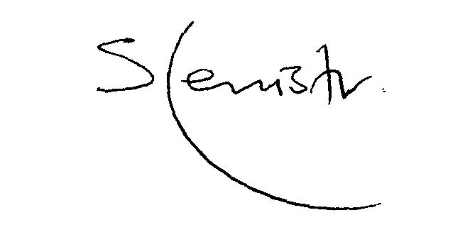

Stephen Leinster

